PROGRAM 3: VACUUM CLEANER PROBLEM
Aim
To write a Python program to implement the Vacuum Cleaner Problem.

Objective
To clean all dirty rooms using a simple vacuum cleaner agent.

Algorithm
- Start in Room A.
- Check whether the room is clean or dirty.
- If dirty, clean the room.
- Move to the next room.
- Repeat until all rooms are clean.
- Display the final status.

Source Code (Simple)
rooms = ["Dirty", "Dirty"]
for i in range(2):
if rooms[i] == "Dirty":
print("Cleaning Room", i + 1)
rooms[i] = "Clean"
print("\nFinal Room Status:")
for i in range(2):
print("Room", i + 1, ":", rooms[i])

Flowchart
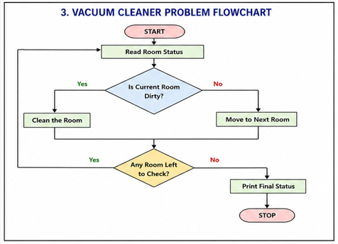
Sample Output

Final Room Status:
Room 1 : Clean
Room 2 : Clean
OUTPUT:
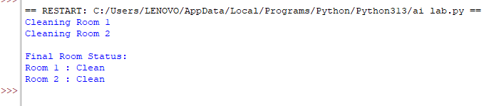
Result
Thus, the Python program for the Vacuum Cleaner Problem was executed successfully.

